19/2 Status Notes

## Overall

* Site tree still needs updating.
* Page designs are going well. At this stage feedback is mostly on the overall design rather than specific aesthetic choices.
* Details on the subscription process aren’t finalised, so we will work on other parts on the project in the meantime and put this component on hold temporarily.
* Designs for web/larger screens are important, we should start getting designs for this underway soon.

## Some Changes

* Agents can upload the contract/s between them and their client as a pdf, viewable by the agent and the client.
* When an agent views a client, they can see a list of properties based on the client’s search criteria.

## Site Tree

From the client side, once they have signed up and logged in:

* Tabbed app: Properties (home), Notifications, Calendar, Me
* Properties: A property list view of properties in the same design as the ‘property search result’ page.
* Notifications: List of updates from agent, or new inspections and appointments
* Calendar: View all available inspections for the properties on the client’s list.
* Me: View the client info (names, emails, phones) as well as the client’s specification (house budget, location, etc.), and contract.

From the agent’s side, once logged in:

* Tabbed app: Clients (home), properties, notifications, calendar, me
* Clients: List of clients (able to filter between all clients and current clients). Each client can be clicked on and go to the client page, dots marking the clients with recent activity.
  + On the client page, we can see the client’s specification, the recent activity for the client, a list of properties that match the client’s search criteria. From the list of properties we can click on a property and choose to add notes and push the property to a client.
* Properties: Includes the property search with search parameters, the link to add a property, and the link to view and manage all the added off-market properties
* Calendar: list of inspections
* Notifications: list of recent activity from clients, as well as new properties found that match a client’s search criteria.
* Me: view agent info, settings

## Page Designs

* Property view:
  + Remove read more button, and have a vertical scroll instead
  + Instead of a link to contact agent, we want to view the agent name and agency, and pressing on that will open the ability to call or email them.
  + Image view should be a horizontal scroll.
* Property list view:
  + More in the style of the apps. Large photo, agent info, address, price, beds, baths and cars
  + A screenshot of a social media post

    Description automatically generated 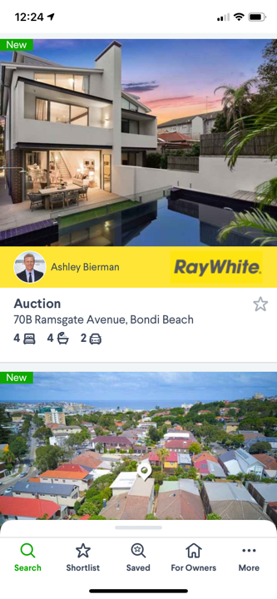 A screenshot of a social media post

    Description automatically generatedA screenshot of a video game

    Description automatically generated A screenshot of a video game

    Description automatically generated
* All login/register/subscribe pages should have the TOB logo
* Add agents page needs to phone number field
* Adding a client and inputting details should be broken into two pages:
  + Page 1: client info as you have it (name, email, phone) however should be able to handle when a client is a couple, i.e. two names, emails and phone.
  + Page 2: inputting of the client specification. This includes their price range, locations, type, size, description etc.
* Adding an off-market property:
  + Title should say “Add Property”
  + First the user searches by address to see if the property is in the database, if it is in the database, the information can autofill in the form. Otherwise the form is left blank.
  + Needs information on the agent selling the house.
  + Text entry instead of sliders
  + Dropdowns instead of buttons
  + All areas in metres squared.
  + No need for additional rows, or a status.